Grammatica

Voorbeeld 1
Van bestaand materiaal:
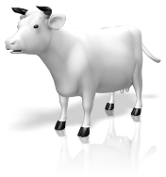 | - Dog
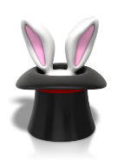 | - Cat
 | - Rabbit
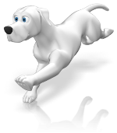 | - Cow

Naar een opdracht waarin een hoger denkproces wordt aangesproken:

Zet deze woorden in de juiste kolom
a clock, a dog, a dress, a mother, black, a pen, bread, a bag, a frog, red, boots, a cat, rice, a man, a baby, pink, a teenager, a hat, a t-shirt, a banana, a book, a sheep, meat, kids, a table, green, an elephant, sugar, white
people | clothes | food | things | colours | animals

Voorbeeld 2
Van bestaand materiaal:
a. unhappy and angry because someone has something you want | 1. angry
b. feeling pleasure or satisfaction | 2. sad
c. lacking interest or energy | 3. jealous
d. having a strong feeling against someone / something that makes you want to shout or hurt them | 4. confident
e. unhappy or sorry | 5. tense
f. nervous, anxious, unable to relax | 6. doubtful
g. uncertain about something | 7. apathetic
h. sure or trusting | 8. happy

Naar een opdracht waarin een hoger denkproces wordt aangesproken:
Complete these sentences.
- I felt angry because…
- I felt sad although…
- I felt jealous when …
- I felt confident so …
- I felt tense although …
- I felt doubtful because …
- I felt apathetic so …
- I felt happy when …

Voorbeeld 3
Van bestaand materiaal:
Vul in:
- Stratford is the town ____ Shakespeare was born in.
  - a. where b. which c. Either could be used here.
- The hotel ____ we stayed was good.
  - a. where b. which c. Either could be used here.
- The man ____ interviewed me seemed friendly enough.
  - a. who b. which c. Either could be used here.
- The British Prime Minister, ____ was interviewed yesterday, denied responsibility.
  - a. who b. that c. Either could be used here.

Naar een opdracht waarin een hoger denkproces wordt aangesproken:
Geef een definitie van de volgende woorden: (grammar: relative pronoun)
Voorbeeld: A hammer is a tool which…
- a cow
- Canada
- a chicken
- a carpenter
- Christmas

